Thrashing

Second one scenario will have many page faults

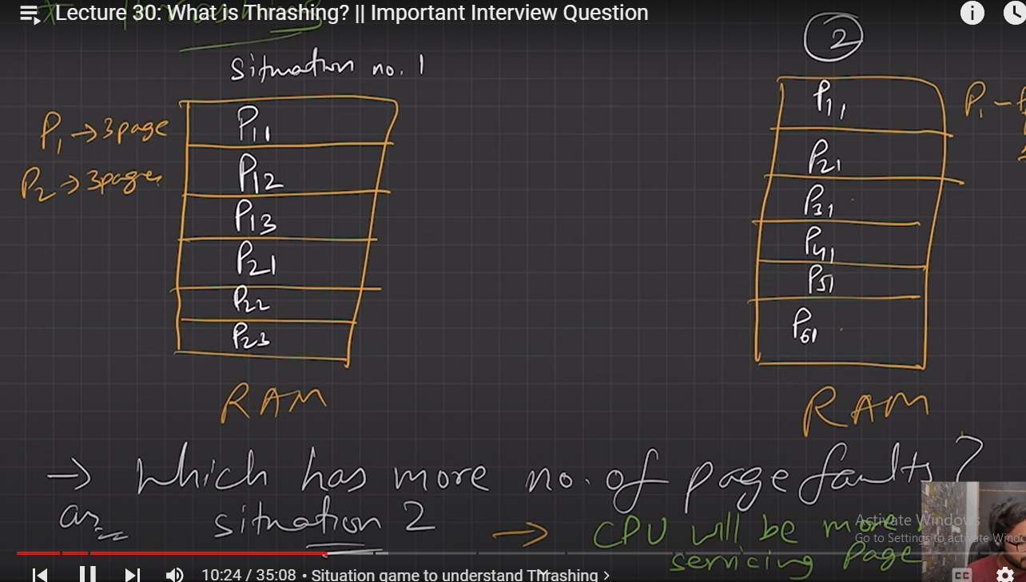

Pij

i – process

j – pageno

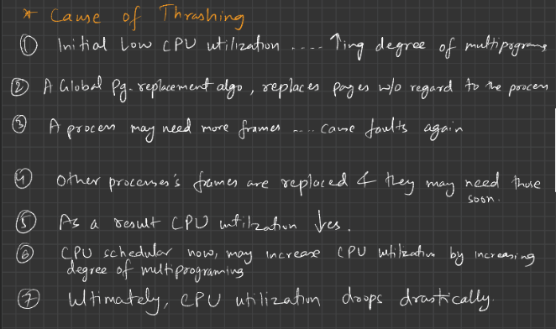

Page Fault frequency:

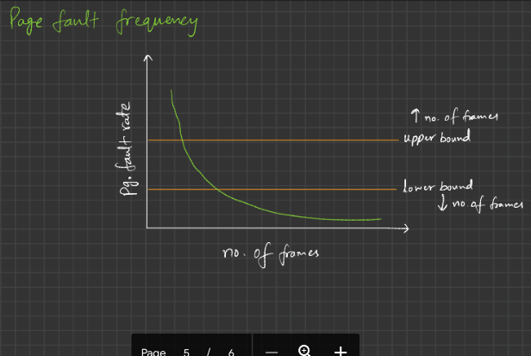

Reference PDF notes

Topics to be looked by own –

Storage management

Files and directories